**HTML5 Sectioning Elements**

HTML5 introduced several sectioning elements that help structure the content of a webpage in a meaningful way. These elements include <article>, <aside>, <section>, <nav>, <header>, and <footer>.

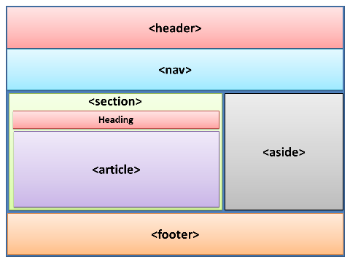

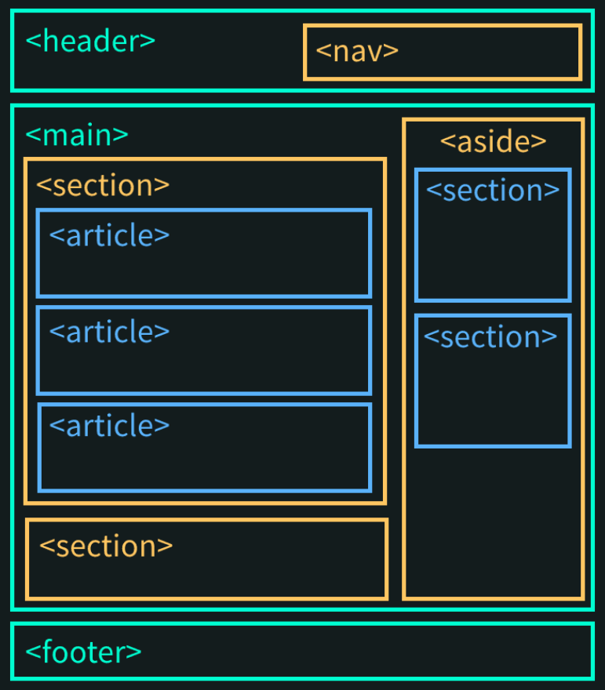

Each element serves a specific purpose and helps organize the different parts of a webpage.

1. <article>:

The <article> element represents a self-contained composition within a document, such as a blog post, a news story, or a forum post. It should make sense on its own and be able to be distributed or syndicated independently.

**Code example:**

<article>

<h2>Article Title</h2>

<p>Article content goes here...</p>

<p>More content...</p>

</article>

**Note:**

* Use <article> to wrap a standalone piece of content that could be distributed or understood independently.
* Avoid using <article> for things like navigation menus, user interfaces, or repetitive content.

1. <aside>:

The <aside> element represents content that is tangentially related to the main content of the page. It is often used for sidebars, pull quotes, advertisements, or other content that can be considered separate from the main content.

**Code example:**

<article>

<h2>Article Title</h2>

<p>Article content goes here...</p>

<aside>

<h3>Related Links</h3>

<ul>

<li><a href="#">Link 1</a></li>

<li><a href="#">Link 2</a></li>

</ul>

</aside>

</article>

**Note:**

* Use <aside> to contain content that is not directly related to the main content but provides additional information or context.
* <aside> should be able to be removed from the page without affecting its overall meaning.

1. <section>:

The <section> element defines a standalone section within a document. It groups together related content. It can be a chapter, a tabbed content area, or any other content grouping that makes sense.

**Code example:**

<section>

<h2>Section Title</h2>

<p>Section content goes here...</p>

</section>

**Note:**

* Use <section> to group related content together.
* Avoid using <section> when more specific semantic elements like <article>, <nav>, or <aside> would be more appropriate.

1. <nav>:

The <nav> element represents a section of a page that contains navigation links. It is typically used to wrap menus, lists of links, or other navigation-related content.

**Code example:**

<nav>

<ul>

<li><a href="#">Home</a></li>

<li><a href="#">About</a></li>

<li><a href="#">Contact</a></li>

</ul>

</nav>

**Note:**

* Use <nav> to mark up a section of the page dedicated to navigation.
* Avoid using <nav> for non-navigation purposes, such as a list of related links.

1. <header>:

The <header> element represents the introductory content or a group of introductory content in a document or a section. It typically contains the page title, logo, or primary navigation.

**Code example:**

<header>

<h1>Website Title</h1>

<nav>

<ul>

<li><a href="#">Home</a></li>

<li><a href="#">About</a></li>

<li><a href="#">Contact</a></li>

</ul>

</nav>

</header>

**Note:**

* Use <header> to mark up the introductory content of a document or a section.
* There can be multiple <header> elements in a document, each representing different sections.

1. <footer>:

The <footer> element represents the footer of a document or a section. It typically contains information about the author, copyright notices, related links, or other metadata.

**Code example:**

<footer>

<p>&copy; 2023 Your Name. All rights reserved.</p>

<nav>

<ul>

<li><a href="#">Privacy Policy</a></li>

<li><a href="#">Terms of Service</a></li>

</ul>

</nav>

</footer>

**Note:**

* Use <footer> to mark up the footer content of a document or a section.
* There can be multiple <footer> elements in a document, each representing different sections.